Lesson Plan – Exploring Patterns & Relations

Developed by: Jana Nicol School: Island View School
Date: September, 2013 Grade level: 2
Subject: Math Unit: Patterns & Relations (PR1, PR2)

Outcomes  PR1: Demonstrate an understanding of repeating patterns (three to five elements).  I can statements  - I can tell about the core of a given repeating pattern  - I can extend a repeating pattern  - I can make a repeating pattern with objects or pictures  - I can find mistakes in a repeating pattern | Materials  - Manipulatives - pattern blocks, cube links, centimetre cubes, counters, number tiles, letter tiles, Wikisticks  - I Can Statements (on PR1.nbk)  - Paper and markers  - Math journals  - Rainstick  - Centre directions (attached to this lesson plan)  - Multiple Intelligences Matrix – Grade 2 Math – PR1 PR2.doc  - Student progress record – Whole class – Grade 2 Math – PR1 PR2.doc  - UDL Guidelines Educator Worksheet.doc
Technology

- Netbooks and teacher laptop/internet access
- http://ivsgrade2.weebly.com (Home/Links/Links for Students/Patterns & Relations Games)
- SMART Board access
- PR1.nbk

Connection to Data/Research

“The foundation of algebraic thinking is investigating patterns and their representations. Contextual, open ended and situation specific problem solving should be an integral part of everyday mathematics instruction, activities and assessment. Students need to recognize and extend many different forms of the same pattern, including those constructed or in their environment. They must identify the core or sequence, and be able to predict an element in repeating and increasing patterns using many strategies within a variety of contexts (e.g., hundred charts, calendars, number lines, tiling patterns). These predictions should be verified by extending the pattern concretely, pictorially and symbolically.” – New Brunswick Grade 2 Math Curriculum, pg. 50.

Prior Learning Connections

In grade 1 students have already demonstrated an understanding of repeating patterns (two to four elements) by: describing; reproducing; extending; creating patterns using manipulatives, diagrams, sounds and actions (PR1).

This lesson follows a review of repeating patterns in grade 2, and an introduction to the I can statements for PR1.

Differentiation
Accommodations for Everyone  - FM system  - Large print materials  - Manipulatives  - Provide tactile/kinaesthetic activities  Accommodations Based on Needs  - Reduced number of assigned questions  - Written directions read to student  - Simplified directions  - Frequent activity breaks  - Extra time  - Teacher selects key questions  - Oral testing  - Scribe  - Evaluation of daily work only | Modifications (SEP-M only)  - Single attribute patterns only (no double attribute patterns)  - Work with repeating patterns of 2-3 elements (instead of 3-5)  - Increasing patterns increase by same amount (e.g. add two each time)  - Provide student with core of the pattern to help them extend it  *These are suggestions only, as specific modifications to curriculum will depend upon the students’ unique abilities and the goals outlined in their Special Education Plan.

Special Concerns

(Classroom management items, medication information, etc).

Assessment

Formative Assessments – To be administered throughout unit on PR1
- Patterns Pre-Assessment.doc
- Student progress record – Whole class – Grade 2 Math – PR1 PR2.doc Throughout the unit, teacher will record students’ demonstration of understanding of each of the outcomes for PR1 and PR2 as they complete activities, journal entries, and participate in discussions.
- Anecdotal notes Record your observations of students’ understandings, areas of difficulty, misconceptions, etc., to guide further instruction throughout the unit.
- Confer with students to provide feedback and help them to set individualized goals.
- Peer assessments Use manipulatives to demonstrate their learning to a classmate, and they can provide their feedback.

Summative Assessment – To be administered at the end of the unit on PR1/PR2
- Patterning Assessment.doc Students will have as many opportunities as needed to rewrite if necessary (students who need it may benefit from oral testing, extra time, and fewer questions, and other accommodations).

Procedure
Before the lesson | Prepare materials (10-15 minutes)  - Group 1 – Open Internet Explorer on each netbook, and open http://ivsgrade2.weebly.com, click on Links for Students and scroll down to the section on Patterns & Relations.  - Group 2 – Put pattern blocks, cube links, number tiles and index cards with sets of instructions for patterns on one table.  - Group 3 – Leave one part of the classroom free (students will make action patterns). Place an index card that outlines the instructions for this group.  - Group 4 – Open PR1.nbk on the SMART board.  - Group 5 – Put paper and markers on one table.  Place students in five groups, make a list to display.  - Groups should be mixed ability.
During the lesson | Repeating Patterns (60-75 minutes)  Review I Can Statements  - Review the I-can statements for repeating patterns:  - I can tell about the core of a given repeating pattern  - I can extend a repeating pattern  - I can make a repeating pattern with objects or pictures  - I can find mistakes in a repeating pattern  Warm-up  - Open PR1.nbk.  - Display the following pattern. Choose a student to label it. Ask the class, is it correct? Explain why or why not.  - Think/Pair/Share – Show the following pattern on the SMART board, ask students if the pattern is correct and explain why or why not. Discuss as a class.  - Choose one student to underline the core of the first pattern. Choose another student to underline the core of the second pattern.  Centres – Practice and Show What You Know  - Inform students they will be working in centres. Briefly review each activity:  - Group 1 – Students will play online pattern games, found in the Patterns & Relations section of http://ivsgrade2.weebly.com.  - Group 2 – Students will make patterns using pattern blocks, cube links, and number tiles. They will share the index cards to make patterns (e.g. one card says ABCDDABCDDABC), and use the Wikisticks to underline the core of the pattern.  - Group 3 – Students will make action patterns. They can make their own (silent) action patterns, and take turns showing them to the members of their group. If time permits, students will make an action pattern together, and once they create a core of the pattern they will extend/repeat the pattern.  - Group 4 – Students will complete the activities on PR1.nbk on the SMART board.  - Group 5 – Students will draw patterns on paper with markers. They will also underline the core of each pattern they make.  - Place students into groups.  - Before sending students to the centres, communicate the expectations for behaviour (working the entire time, keep voices down, remain on task, “ask three then come to me” if you need help).  - Observe students and take anecdotal notes. Take note of which students appear to easily grasp the concept, and those who seem to be struggling to guide further instruction. Use the Student progress record – Whole class – Grade 2 Math – PR1 PR2.doc to record students’ progress.  - Centres will switch every 8-10 minutes. Use the rainstick to remind students to move onto the next activity.  Share/Reflect  - After students have had a chance to complete all of the centres, whole class will meet on the floor.  - Ask students who are willing to tell the teacher what they have learned today.  - Have students show their understanding through a quick ‘thumb survey’. Students will close their eyes and participate in the thumb survey. Thumbs up means they really get it, thumbs to the side means they kind of get it, and thumbs down means they don’t quite get it yet. | UDL Guidelines  3.1 – Activate or supply background knowledge  2.3 – Support decoding of text, mathematical notation, & symbols  2.4 – Promote understanding across language  8.3 – Foster collaboration & community  5.3 - Modelling  3.3 – Guide information processing, visualization, & manipulation  3.4 – Maximize transfer & generalization  4.1 – Vary the methods for response & navigation  7.1 – Optimize autonomy (flexible groupings)  8.3 – Foster collaboration & community  5.2 – Use multiple tools for construction & composition  9.3 – Develop self-assessment & reflection
After the lesson | 10-15 minutes – Students will choose one of the following prompts and respond to it in their Math journals, and use words numbers and pictures to explain their ideas:  “Why do we need to know the core of a pattern?”  “How can you tell if a pattern is incorrect?”  “Draw and label as many patterns with 4-5 elements as you can” (in the time provided).

Reflections

Group 1 - Play Online Games

Choose one or more games to play on the netbook.

Open Internet Explorer.

Type http://ivsgrade2.weebly.com

Click on Links for Students
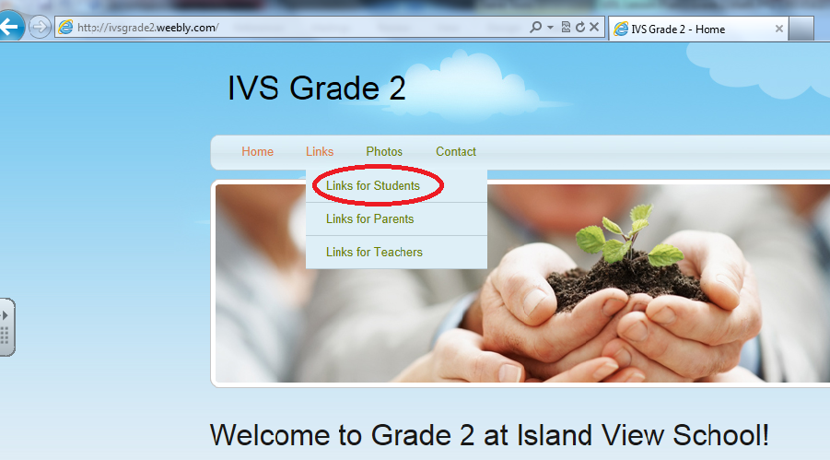

Scroll down to Patterns & Relations
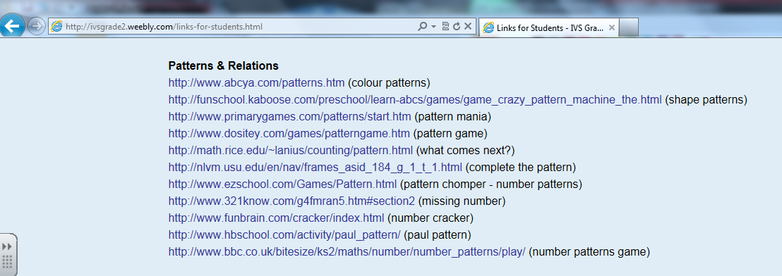

Click on any game in the list to play.
Group 2 – Making Patterns

You can use any of the objects on this table to make a pattern.

Use the Wikisticks to underline the core of the pattern.

When you finish, choose another pattern to make and underline the core of the pattern with the Wikisticks.

Set 1  A B C A B C A B C  A B C D A B C D A B C D  A B C C A B C C A B C C  A A B B C C A A B B C C A A B B C C  A A B C C A A B C C A A B C C | Set 2  A B C D A B C D A B C D  A B B C D A B B C D A B B C D  A A B C C D A A B C C D A A B C C D  A B C D B C A B C D B C A B C D B C  A B B C D B A B B C D B A B B C D B | Set 3  A B C D E A B C D E A B C D E  A B C D D E B A B C D D E B A B C D D E B  A B B C D E E C A B B C D E E C A B B C D E E C  A A B B C C D E A A B B C C D E A A B B C C D E

Group 3 – Action Patterns

You will make your own action pattern.

Here are some ideas for actions you can do.
- Raise your hand
- Flap your arms like a chicken
- Plug your nose
- Wiggle your feet
- Or anything else you can think of!

Actions should be silent.

Put 3, 4, or 5 different actions together to make the core of your action pattern, and repeat the pattern.

Take turns sharing your action pattern with your group.

If you have enough time, make an action pattern as a group.

Group 4 – SMART Board

Do the activity that is on the SMART board.

When you finish one page, go to the next page.

Do the pages in order.

Take turns.

Group 5 – Drawing Patterns

Use the markers to draw a pattern on paper.

Your pattern should have 3, 4, or 5 elements.

Your pattern could have different shapes, colours, letters, numbers, or words.

Label the pattern and underline the core.

When you finish, draw a different pattern.

