Shape Riddle By: ___________________________

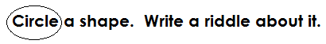

circle oval triangle square rectangle rhombus

parallelogram trapezoid pentagon hexagon octagon

Choose 3 or more of the clues to make your riddle.

I have _______ straight sides.

I have _______ corners.

I have _______ vertices.

I have _______ horizontal lines, ______ vertical lines, and ______ diagonal lines.

I am shaped like a ____________________________.

What am I?

